***Project Management Assessment1***

| Name of Student | Shimpei Oshikiri | ID | 70359 |
| --- | --- | --- | --- |

**Assessment 1 – Case Study**



**Contents**

Instruction: 2

Duration: 2

Case Study: 2

Going Green application, Green IT Project Management 2

Project profile 2

Here is my software running on my phone! Or Access by: 4

Business situation 4

Your tasks: 5

Task 1: Identify Business Strategy and Gap 5

Analyse Strategy 5

Task 2: Recommend a feasible solution 6

Task 3: Produce a Project Charter 6

Task 4: Project Document 8

Task 5: Project Closure 9

Helpful web links to complete the assessment: 12

Search Index 13

## Instruction:

This task is to be completed individually. You need to analyse a case scenario and complete all the tasks mentioned after the scenario.

You need to demonstrate your IT project management ability to identify business strategy and gaps. You will also need to suggest a feasible solution to overcome identified gaps and produce a project charter along with a WBS to implement the proposed solution.

### Duration:

Trainer will set the duration of the assessment.

## Case Study:

### Going Green application, Green IT Project Management

# Project profile

Going “Green” is a mission of many companies around the globe not just for reasons of environmental responsibility, but also for cutting costs in these extremely tight economic times. Green IT efforts represent a specific focus area within enterprises that hold attention to this trend. Green IT leverages information technology to streamline operations, cut costly waste, and reduce the impact on the environment. IT typically consumes only about 10% of an organization’s energy costs, but the net effect of a Green IT project is to go beyond just energy saving. To tackle the other 90%, a Green IT project extends into a variety of other departments, and to execute such an endeavour requires an effective project management function in order to identify and prioritize goals. A Green IT transformation can be a complex process.

Vital Statistics:

* Number of project tasks - 12
* Project duration - 16 months
* Project budget - $1,200,000
* Number of users - 50

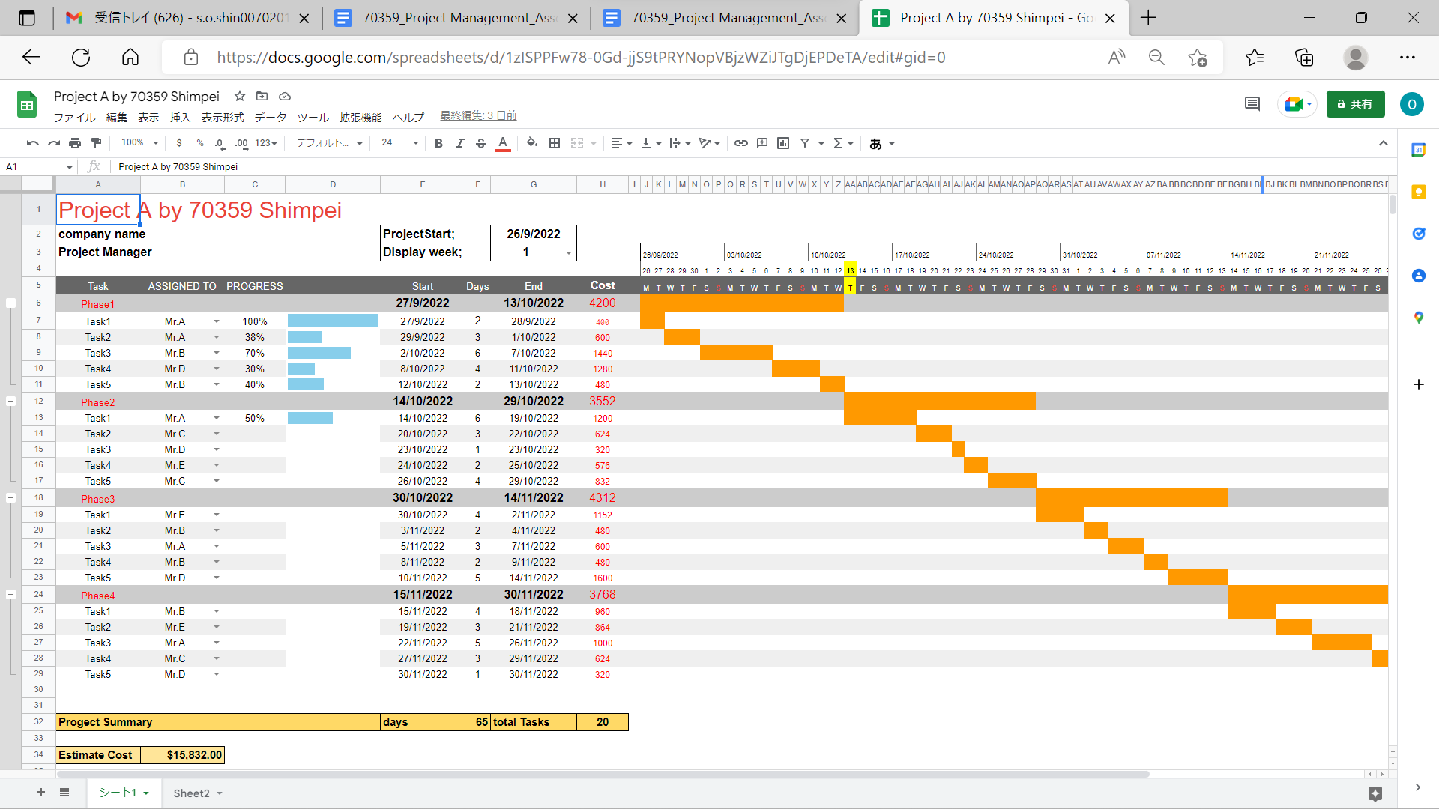

refer : <https://docs.google.com/spreadsheets/d/1zISPPFw78-0Gd-jjS9tPRYNopVBjzWZiJTgDjEPDeTA/edit?usp=sharing>

I made a Gantt chart using a Google spreadsheet because it is a popular tool nowadays and easy to share with project teams.

## Your tasks:

### Task 1: Identify Business Strategy and Gap

Document the business’s strategies of “Green IT” and also summarise the components required changes for the participating organisation to implement “Green IT Project”. (Min. 300 words)

### ------------------------------------------------------------------------------------------------------------------------------

### “Green IT” is a computer technology strategy that is considered a global environment. Green IT must be thought through whole things related to climate changes, such as lack of resources, rising CO2 and sea level, and global warming.

**Computers and computing typically need a lot of natural resources from raw materials for being manufactured and running.**

**Today, All businesses ,including small and big, rely on computer technologies.Everybody has IT devices like smartphones, PCs, and laptops and they use them in their daily life frequently. IT technologies are essential things for human beings and their manufacturing cycle is so fast.**

**“Green IT” is not only for the global environment, but also for increased sustainable productivity and cost reduction for organizations.**

**The concept involves a set of more ecological practices,including cloud storage, improved energy consumption,modernization of equipment to increase its useful life, and efficient disposal policy.**

### To turn into a “Green IT”,you must set a goal and plan business strategies by analysis.It helps you to recognize a gap between present and the goal and deal with it clearly.

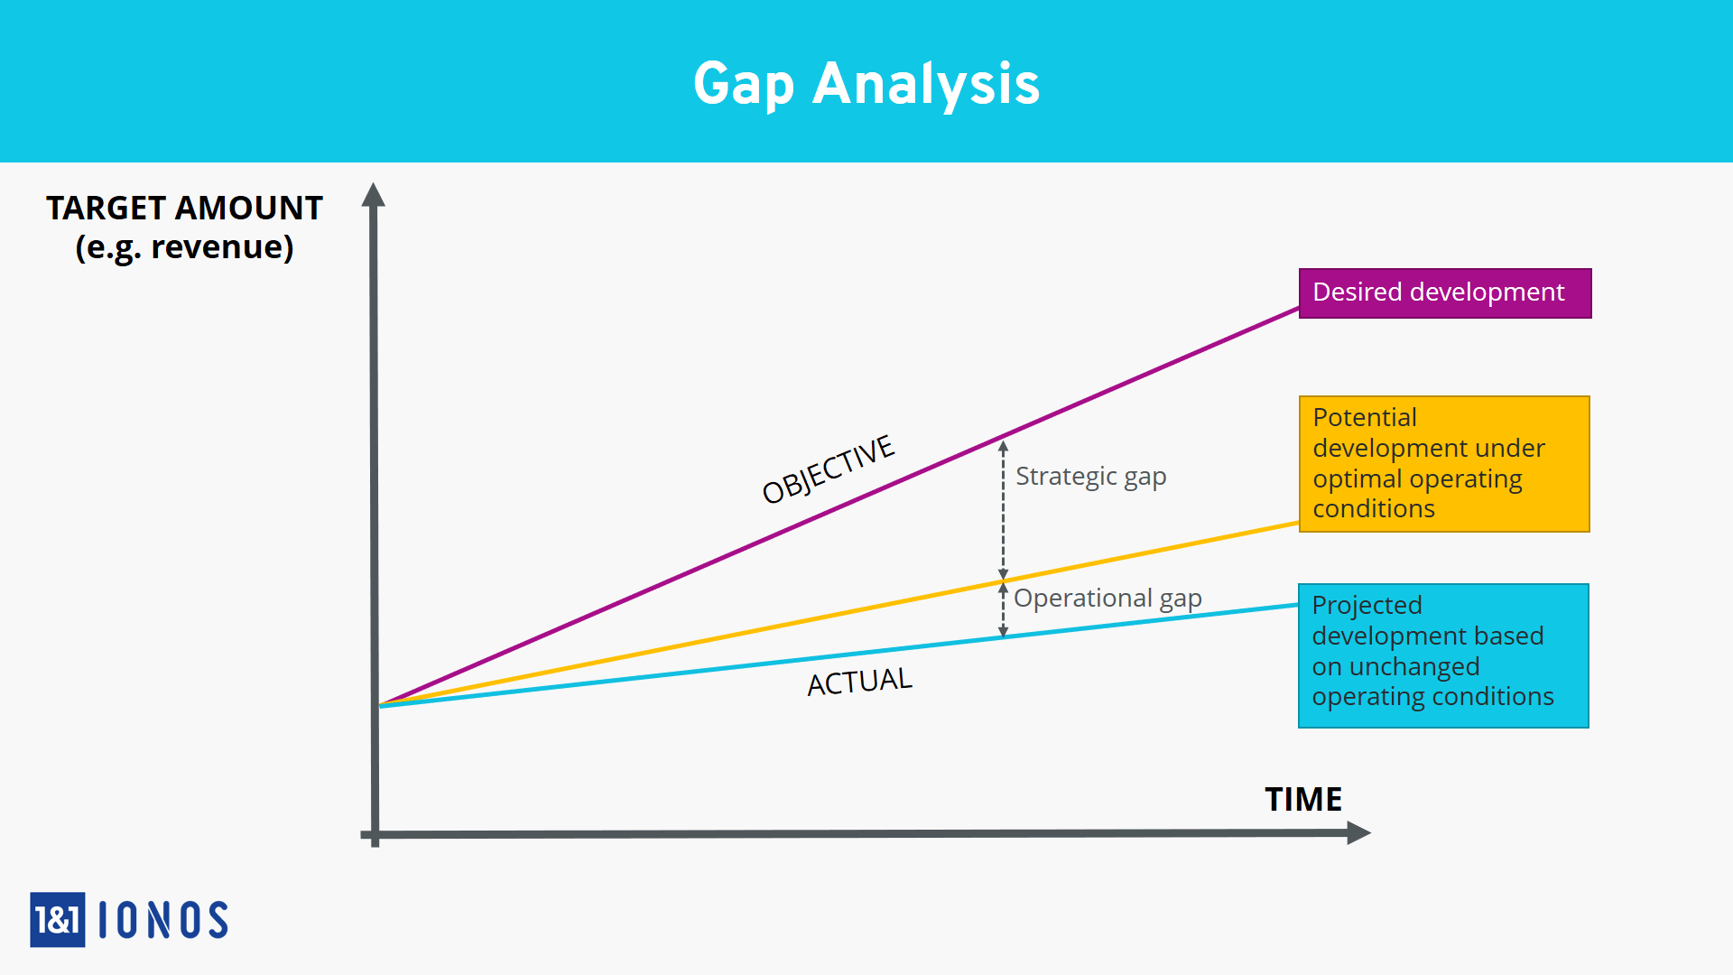

**Hiring an outside party is a good way to fill the gap for you. You will get your business structure more flexibility and lower costs throughout the business cycle.**

**You also have to understand about ISO 14001, which is the determination of environmental management systems for using “Green IT” and follow the ISO14001 prosecce .**

### 

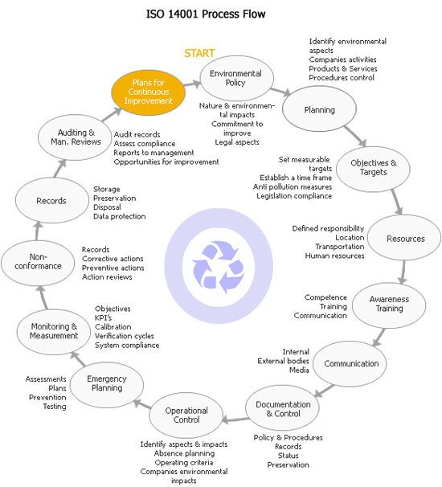

**To keep your project without slowing down, it would be better to have a conversation so often with your team without wasting chat time.This is a good thing for making your team around the right way.**

**These are 10 tips to be Green IT.**

**1.Replace older hardware with new hardware**

**2. Use a virtualized environment where possible**

**3.Make use of the energy efficiency setting offered by the hardware and virtualisation layer**

**4.Provide a measurement infrastructure for determining energy KPIs during the rollout of the application in its production environment.**

**5.dare to consider approaches that lead to more energy effective solution**

**6.Limit the oversizing of systems**

**7.Recognised availability requirements**

**8.Only activate the test and failover environment when needed**

**9.Optimise for performance**

**10.Take the workload pattern into account when sizing the system**

### Task 2: Recommend a feasible solution

Assume “Wells International College” is thinking of going “Green” and asked for your assistance in this project. Research different project management applications on the Internet to compare with the Green IT project management application and recommend a feasible solution with proper reasons for Windsor. (Min. 300 words)

Example; Tesla PTY LTD

REFER: [Feasibility Study Examples | Practical Examples with Excel Template (educba.com)](https://www.educba.com/feasibility-study-examples/)

Tesla LDT wants to start a new solar power project with a life of 8 years. Mr. Will Smith is the project manager and he performs an economic feasibility study about the project and reports. At first, he researched the solar power field and estimated their cost. It said--

・State Government provides a tax free subsidy for $1.25 million dollars on initial capital investment at that time.

・The starting cost is estimated around $17.5 million and also the company will be required some additional equipment for $1.25 million in 5 years.

・The working capital requirement at the initiation of the project is $2 million.

・The estimated sales volume over the 8 year period is--

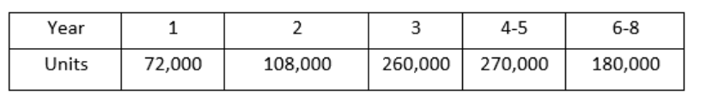

・Expected sales price = $120 per unit and variable expenses will amount to 60% of sales revenue.

・The managing cost will be $1.8million every year.

・Tesla is subjected to a tax rate of 30%.

Mr.Smith calculates the net present value of the project (NPV) by discounting the cash-flows at 12%.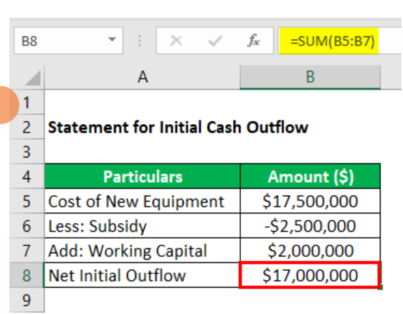

This is a statement for initial cash flow--

They also calculate their depreciation for 8 years.

Statement of Net cash inflow said they are going to lose its first year with no tax but would get profit in the last 2-8 years.

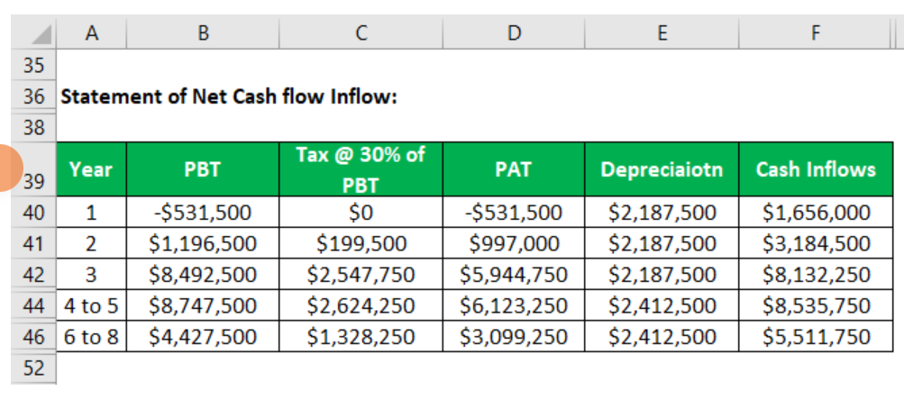

statement for calculation discounted cash flows

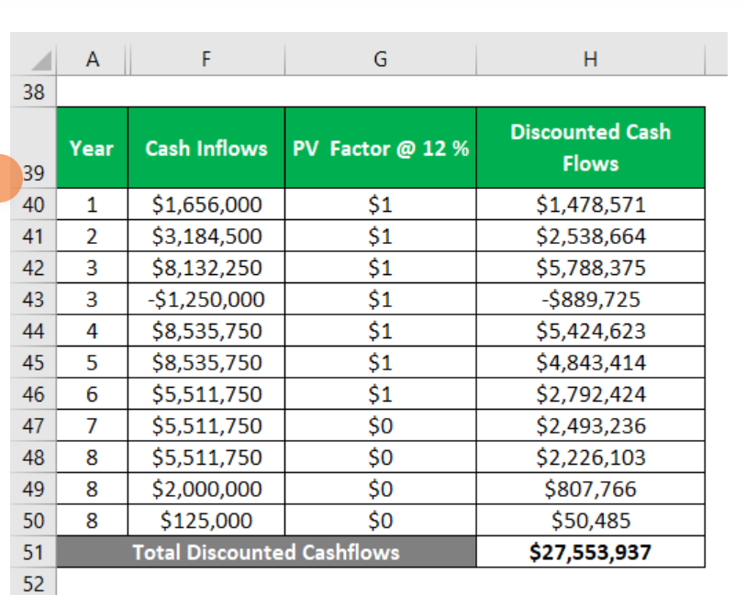

so NPV is

$27,553,937 - $17,000,000 = $10,553,937

Speaking of the analysis, this project gives Tesla high profit. Tesla should accept this report and start this project.

If this calculation was negative, Mr, Smith would talk to his boss to drop the project and not to produce the solar products. The decision saved the company against loss of resources,time and plenty of money.

The feasibility analysis is the most important test that every entity should perform in advance while undertaking a new project.It gives a clear picture of the proposed project and helps the management to choose the best out of various alternatives available by providing valid reasons to accept one and reject the other.

### Task 3: Produce a Project Charter

### A project charter is a short document that explains the project in clear,concise wording for high level management.

Project charters outline the entirety of projects to help teams quickly understand the goals,tasks, timelines,and stakeholders.

The project charter is required that it is written in brevity and clear so that everyone can understand the overall of the project.

When you prepare the project charter, the main components are

1.Problem statement

2.Business case

3.Goal statement

4.Timeline

5.Scope

6.Team members

*example of project charter

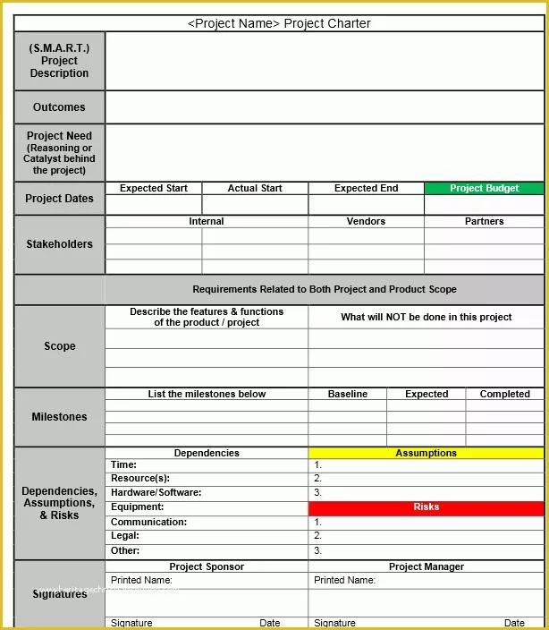

### Task 4: Project Document

Refer to your current project, you have been asked to develop a project plan for WIC. Project plan outline as following:

In my Green project, I design following topics:

* Introduction (Select one recommendation from Task 2 for implement project plan)

(Please see above my project charter, it is clear indication)

* Project background

(Make promotion video for the college)

* Related factor to organization
* Scope and objective of the project
* Information gathering plan and approach
* Gathering method, can be one of the following
* Interview
* Questionnaire
* Observation
* Detail of information repositories
* Feasibility studies
* Technical (need higher tech made this software more stable and powerful)
* Operational
* Economical
* Social
* Project plan and schedule (Development and Maintenance)
* Work breakdown structure
* Gantt Chart
* Milestone

Above last black diamond is the milestone!

* Project Deliverable
* Communication plan

Communication plan should include communication and consultation with all the relevant stakeholders. (From college learn guide)

* Deployment Plan (If needs)
* Training Plan (If needs)
* Recourse and budget, (budget has been limited by WIC Capital Expenditure of current fiscal year for Hardware $80,000, Software $10,000, and Outsourcing man-hours $100,000)

Above image is showing my current green project displaying part of budget!

* Risk Management
* Risk identified
* Contingency plan
* Change management
* Change control
* Conflict management

### Task 5: Project Closure

Prepare project closure document template as following:

When project sign off, it means your project finished. So you need make one clear sheet to tell everyone about your project. It will include:

* project start date
* Project Sign-off document
* project manager
* project finish date
* if something is going wrong
* project goal
* project deliverables
* clients

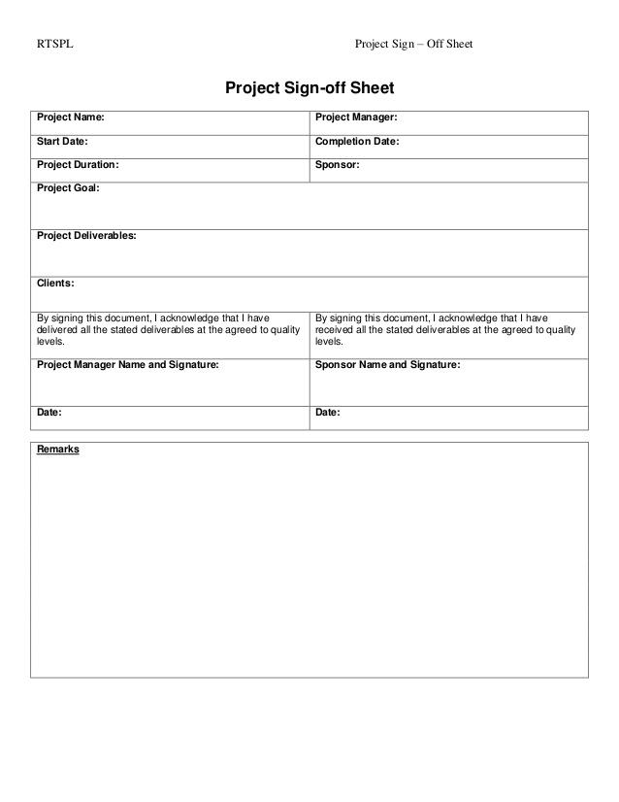

* Project evaluation document

You need to show your project, good or not enough. Summary all about your project

It may include:

* Budget evaluation
* Quality evaluation
* Benefit evaluation
* planning evaluation(time keeping, dead line)
* task evaluation
* risk evaluation(if an issue happened. how serious is the issue.)
* strategic or technical issue

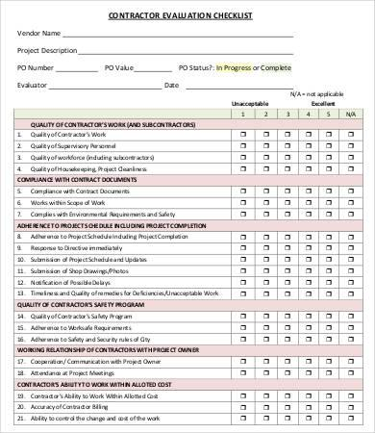

* Lesson learned template
* What we have learnt through this project
* What we need to do if next project start
* What we learn some lessons. We could not make the same mistake again.
* Recognition through the project
* How will we avoid taking same mistake again
* Is there a better way than what we have done in the project?

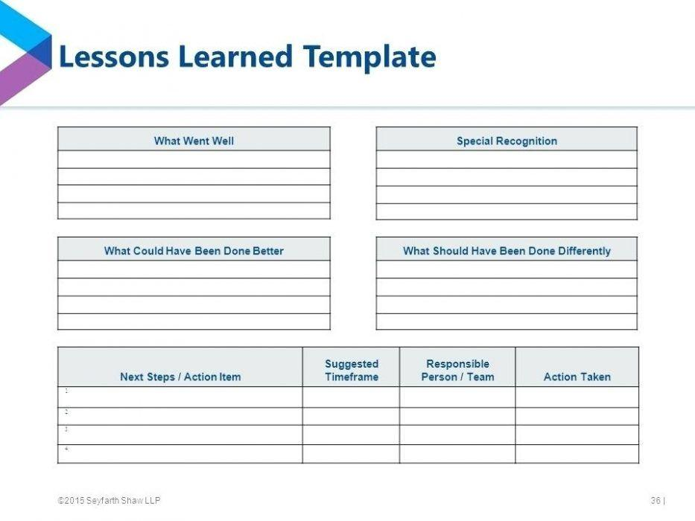

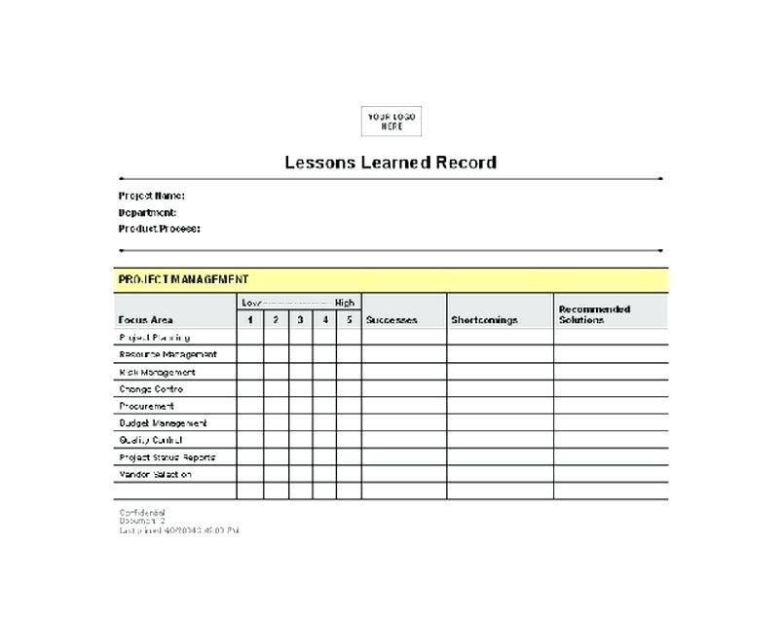

This is my web page for Project Management

## 

[Project Management (shimpei70359.github.io)](https://shimpei70359.github.io/ProjectManagement/)